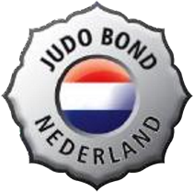
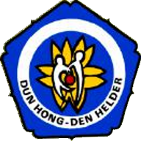
International Den Helder Open
Judo Championships 2017

The DUN-HONG Budoclub hereby invites you to the

40th International Den Helder Open Judo Championships,

which will be held on the 25th and the 26nd of November 2017

at the Sportcenter, Schootenweg 2, 1785 LV Den Helder.

The tournament is approved by the Judo Bond Nederland under number JBN2017-0126.
Clubs from England, Ireland, Belgium, Germany, Wales, Scotland, France, Hungary, Finland, Israel, Poland, Czech Republic, Denmark, Croatia, Austria, Luxemburg, Switzerland, Macedonia, Norway, Sweden and of course The Netherlands will be invited.

Enrollment occurs through an email to: ohkjudo@gmail.com

Closure date enrollment: Sunday 5. November 2017

Application fee: € 10,00 per person

Further information:

Each delegation may nominate a maximum of 10 judokas whose results count towards a club Cup. A first place gives 3 points, a second 2 points and a third 1 point. At the end of each competition day we have the Club Award ceremony. There is no entry fee for this competition.

In order to ensure the continuity of the tournament, the OHK-organization finds it necessary to enforce more stringent rules. Please make sure to become familiar with these rules in the tournament conditions. Compliance with the tournament conditions (which are attached to this invitation) will be assumed upon enrollment.

Saturday 25 November 2017 |  |  |  | 1 | 2 | 3 | 4 | 5 | 6 | 7 | 8 | 9
Cat A  (- age 8) | Boys | ‘10 en ‘11 | Weigthclass | -18 | -21 | -24 | -27 | -30 | -34 | -38 | +38
Cat B  (- age 8) | Girls | ’10 en ‘11 | Weigthclass | -18 | -20 | -22 | -25 | -28 | -32 | -36 | +36
Cat C  (- age 10) | Boys | ’08 en ‘09 | Weigthclass | -21 | -24 | -27 | -30 | -34 | -38 | -42 | +42
Cat D  (- age 10) | Girls | ’08 en ‘09 | Weigthclass | -20 | -22 | -25 | -28 | -32 | -36 | -40 | +40
Cat E  (- age 12) | Boys | ’06 en ‘07 | Weigthclass | -24 | -27 | -30 | -34 | -38 | -42 | -46 | -50 | +50
Cat F  (- age 12) | Girls | ’06 en ‘07 | Weigthclass | -22 | -25 | -28 | -32 | -36 | -40 | -44 | -48 | +48
Cat G  (- age 18) | Men | ’00,’01,’02 | Weigthclass | -46 | -50 | -55 | -60 | -66 | -73 | -81 | -90 | +90
Cat H  (- age 18) | Ladies | ’00,’01,’02 | Weigthclass | -40 | -44 | -48 | -52 | -57 | -63 | -70 | +70
Sunday 26 November 2017 |  |  |  | 1 | 2 | 3 | 4 | 5 | 6 | 7 | 8 | 9
Cat I  (- age 15) | Boys | ’03,’04,‘05 | Weigthclass | -34 | -38 | -42 | -46 | -50 | -55 | -60 | -66 | +66
Cat J  (- age 15) | Girls | ’03,’04,‘05 | Weigthclass | -32 | -36 | -40 | -44 | -48 | -52 | -57 | -63 | +63
Cat K  (+ age 18) | Men | ’99and earlier | Weigthclass | -55 | -60 | -66 | -73 | -81 | -90 | -100 | +100
Cat L  (+ age 18) | Ladies | ’99and earlier | Weigthclass | -48 | -52 | -57 | -63 | -70 | -78 | +78

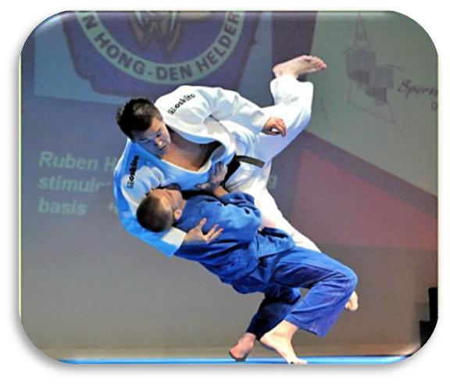

***********General Tournament Conditions***********

Enrollment
Enrollment occurs through an email to ohkjudo@gmail.com by means of the supplied digital Excel (XLS) entry file.

The following information is required:
- Club information, (email) address, telephone number, contact person
- First name and last name competitor 3. Year of birth competitor
- Memb.nr. Nat. Fed.
- Kyu / grade
- Category and weightclass competitor

Enrollment is per person and requires full payment of the application fees. Confirmed enrollment occurs after the payment of the application fees.

The closure date for enrollment is Sunday November 5th 2017, or - the maximum amount of 1000 participants is reached.

Application fee
The application fee of € 10.00 per person must be immediately transferred upon enrollment to bank account 61.54.84.867 (ABN/AMRO) account of H.A.B.C. Dun Hong, Den Helder, The Netherlands.
Number IBAN: NL86ABNA0615484867. Number BIC/Swift: ABNANL2A
Please also supply the following extra information with the transfer: O.H.K. 2017, the name of your school/club and the number of participants.

All participants must be members of the Judo Bond Nederland, or for foreign participants must be members of their own national organization. Judo passports and membership cards for 2017 are required and will be checked. The OHK-organization will not refund any application fees after enrollment, except in the case that the organization cannot guarantee participation.
Before the tournament the participant will receive information about the program and weighing times. Weight cards will be given to the coaches after the definitive enrollment at the tournament.

Weight changes and other mutations
Changes in the reported Weight Class can be submitted - November 12th 2017 per e-mail: ohkjudo@gmail.com. The weigh-in is strict. If a participant exceeds the weight limitation, he/she will be excluded from participation

Tournament organization
The OHK-organization has the right to combine Weight Classes and/or age classes with less than 6 participants without having to issue a refund. Participants will be informed about this in advance. F or participants in categories from I and J there is a minimal age of 12 years.

For categories G, H (2000) and I,J (2003) there is the possibility of a double start in an older age group, with consideration for the minimum age for these groups in accordance with the rules of the JBN/EJU.

Boys and girls will be placed in separate groups, also in the youngest age categories.
The tournament system on Saturday for the youth -12 will be: round-robin. For the youth -18 on Saturday will be a double elimination tournament system up - the finals. The tournament system for Sunday will be double elimination up - the finals.

Per 10 participants one coach card will be given.

